Short-form compliance and quality history

Service name: Next Step Childcare
Date report generated: 06/11/2025
Service ID: SE-40016296
Provider ID: PR-40001637
Provider name: Jane Underwood

Every ECEC service in NSW is now required to display their compliance and quality history. This information is to help families better understand safety in their child’s service.
Type of Action | Area of non-compliance | Date issued | Status
 | Our service has no statutory compliance history to display

Quality Rating | Date issued
Meeting | 16/11/2023

Your service has filled in this template, so that you can see a short-form version of their compliance and quality history. It covers the past 2 years of compliance history (or to the date the service was approved or transferred to the current approved provider) along with the current and previous quality rating. It also includes any offences for which the service has been prosecuted where there is a plea of guilt, finding of guilt or a conviction.
The NSW Early Childhood Education and Care Regulatory Authority undertakes monitoring and compliance activities to ensure the health and safety of children.
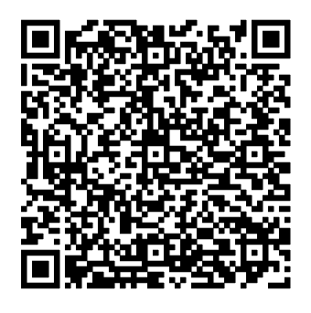
For more information speak to your service, scan the QR code or contact the NSW Early Childhood Education and Care Regulatory Authority on 1800 619 113 or via ececd@det.nsw.edu.au

